# Verona L-Desk with Return

Description $1800

Love where you work. That's the goal, right? Well, the Verona L-desk with return has what it takes to get you there. Eight drawers, including two that are felt-lined, offer plenty of storage. Cable cutouts provide a simple way to avoid cluttered wires. Plus, an antique oak and matte-black finish is simply stunning.

Product Details

Dimensions (in)

L: 69" x W: 75" x H: 31"

Color

Antique Oak/Matte Black

Style

Transitional

Finish

Oak Dark

Finish Treatment

Distressed Finish

Weight

377 lbs

Weight Capacity

230

Desk Shape

L-Shape

Desk Type

All Sides Finished, Computer Desk

Care

Dust with a soft, dry cloth. All spills should be cleaned up immediately.

Vendor

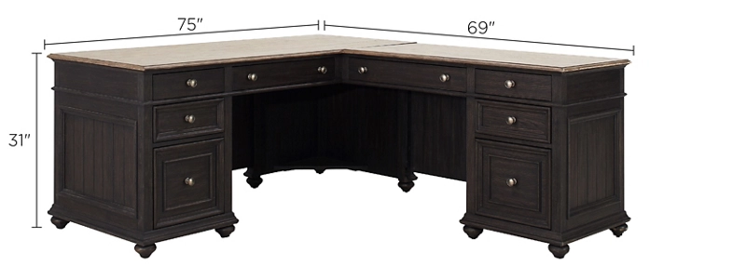Riverside Furniture